[STUDY NAME] Parking Directions

Thank you for joining the [STUDY NAME] study! This packet includes directions to the most convenient parking space for the day of your appointment. The *Learning & Longevity Research Network* is located at:

Research 1

4353 Scorpius Street

University of Central Florida

Orlando, FL 32816 ‎

The Research 1 building is quite new, so your GPS directions may not be quite sufficient. You can find the location on the online campus map at: <https://map.ucf.edu/locations/research-1/>. We are also including an illustrated map of the entire campus with a detailed inset showing the location of the *Learning & Longevity Research Network* **24 hour reserved** **parking spaces**.

When you arrive, you should approach the parking lot from Gemini Boulevard by turning onto Scorpius Street, as if you were going to park in Garage C. Instead, you should follow Scorpius Street to the northeast corner of the Research 1 building, where you’ll find the parking lot between Garage C and Research 1. Scorpius Street is a loop, so either entrance will lead you where you need to go.

The reserved parking spaces are near the southeast corner of this parking lot, and marked by signage, of which you can see an example below. If you decide to park in another structure, like the nearby Garage C, please make sure your parking location is authorized by your existing UCF parking permit.

Your researcher will be waiting for you in the lobby of the Research 1 building at least 10 minutes before your scheduled appointment time. If you arrive early, you may wait in the lobby or head up to suite 350 on the third floor, where there will be additional seating while you wait.

If you have any questions at all, or any trouble finding us or following these directions, please feel free to call our main lab phone at **407-823-2311**.

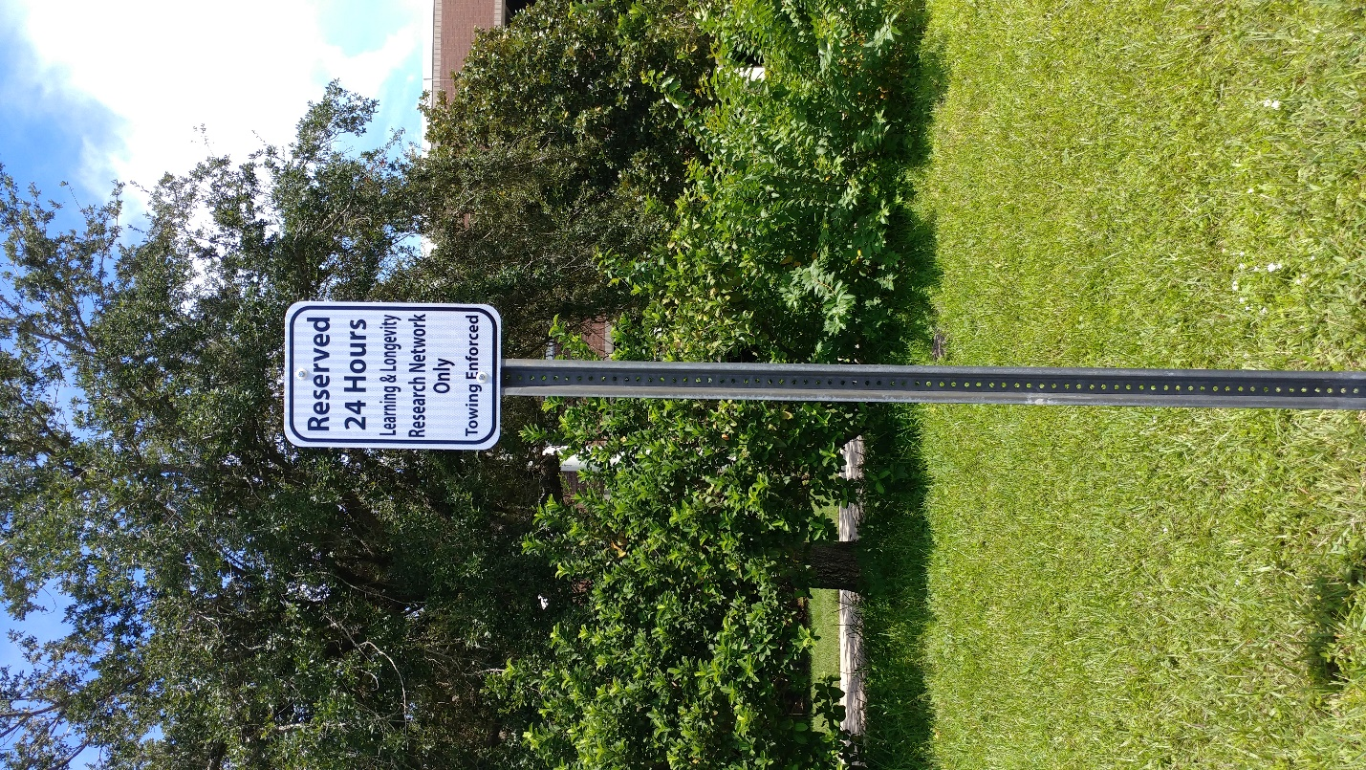We look forward to seeing you soon!

Nichole Lighthall, Ph.D.

Assistant Professor

Department of Psychology

University of Central Florida

